Programming Foundation With Pseudocode
- Write a pseudocode to accept one of the below Rating from the user, then Identify the Feedback. Accept the Rating should not be less than or equal to one and should not be greater than 10. Accept the type of service they have taken and the vehicle details like Type and Cost of Vehicle to calculate total amount to be paid for the service. Make use of best practices and exception handling.

Rating | Feedback | Vehicle Type | Type of Service | Cost of service
1-5 | Poor | All | F | 200
5-7 | Average | Hatchback | BR | 15% cost of vehicle
8-9 | Good | Small Cars | BR | 10% cost of vehicle
10 | Excellent | Sedan | BR | 18% cost of vehicle
Table 1
*F = Free Service *BR = Body Repair

HTML and JavaScript

- Design a web page to accept customer and vehicle details using HTML 5 and CSS and perform the following validations.

- All fields are mandatory (none can remain blank)
- Sur Name should be using list box
- State and City should be populated via List boxes in association with each other.
- Customer Name should accept only alphabets with length greater than 5.
- Email id should be valid Email Id
- Mobile number should be of 10 digits.
- Pin Code of 6 digits includes space Eg: xxx xxx
- Car model should be from an drop down list.
- Write a javascript function to
  - Validate whether Type of Service is selected or not.
  - “Your Feedback” should accept numeric input in the range of 1-10 alone and based on the input respective “Feed Back” as you refered in the above “Table 1” should be displayed in the same Text box.
- If all the data is valid display the following message in an alert box while clicking on “Submit” button .

“Thanks for your Valuable Feedback <<SurName>>.<<CustomerName>>.”

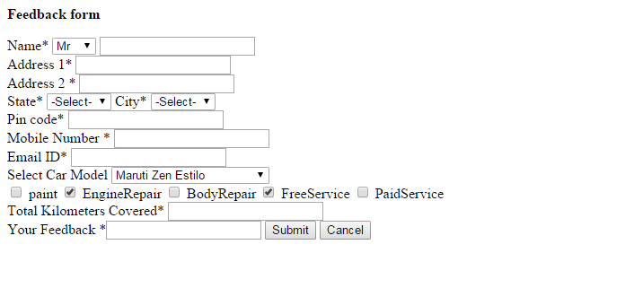

Oracle - Refer the table script for answering questions:

DROP TABLE customer;

CREATE TABLE customer(
cust_id NUMBER(4) PRIMARY KEY,
cust_name VARCHAR2(20),
email VARCHAR2(40),
mobile NUMBER(10),
address VARCHAR2(50)
);

INSERT INTO customer VALUES(2001,'Rohini','rohini@igate.com',8989898989,
'Pune');
INSERT INTO customer VALUES(2002,'Satyen','satyen@igate.com',8765457899,
'Mumbai');
INSERT INTO customer VALUES(2003, 'Rashmi', 'rashmi@igate.com', 9867563423, 'Bangalore');
INSERT INTO customer VALUES(2004,'Bala','bala@igate.com',7856432311,'Chennai');

CREATE TABLE Feedback(
Feed_BackID NUMBER(4) PRIMARY KEY,
cust_id NUMBER(4) REFERENCES customer (cust_id),
Vehicle_NO VARCHAR2(20), Vehicle_Type VARCHAR2(10),
Service_date DATE, Rating NUMBER(2)
);

INSERT INTO Feedback VALUES(3001, 2001,’TN 03 A1234’,’Sedan’,'26-JUN-14',8);
INSERT INTO Feedback VALUES(3002,2001,’KA 05 K3456’,‘HatchBack’,'13-MAY-14',7);
INSERT INTO Feedback VALUES(3003,2002,’MA 15 M6789’,’SmallCar’,'20-FEB-14',10);
INSERT INTO Feedback VALUES(3004, 2001,’TN 07 H4567’,’Luxry’,'26-JUN-14',6);
INSERT INTO Feedback VALUES(3005, 2003,’KA 12 Y5567’,’SUV’,'17-AUG-14',9);
INSERT INTO Feedback VALUES(3006, 2001,’KL 09 O8989’,’Compact’,'10-JUL-14',4);
COMMIT;

CREATE SEQUENCE Feed_Back START WITH 3007;

Note: Solve all Questions

- Write a procedure which accepts Vehicle_Type and displays customer details who all have that Vehicle Type in the following format.

Vehicle_NO Customer Name Email Mobile Address

Note: If entered Vehicle_Type doesn’t exists in the table, then throw exception with message “Vehicle Type of <<Vehicle_Type>> None has serviced at This Service Facilty”. Write a PL/SQL block to call this procedure.

  - Retrieve Feed_BackID and name of the Customers who all Gave “Excellent” Rating.
  - Write a query to get count of Rating is more than 8.

- Write a SQL query to interactively insert a record into the Feedback table. Make use of the mentioned sequence to generate primary key value and insert value to Feed_BackID column. Service_date should be current date.

XML
- Write XML document based on HTML document in section 2.
- Create a Schema for the XML file and validate the XML file

